ULTRAFLEX MODBUS COMMUNICATION SOFTWARE MANUAL

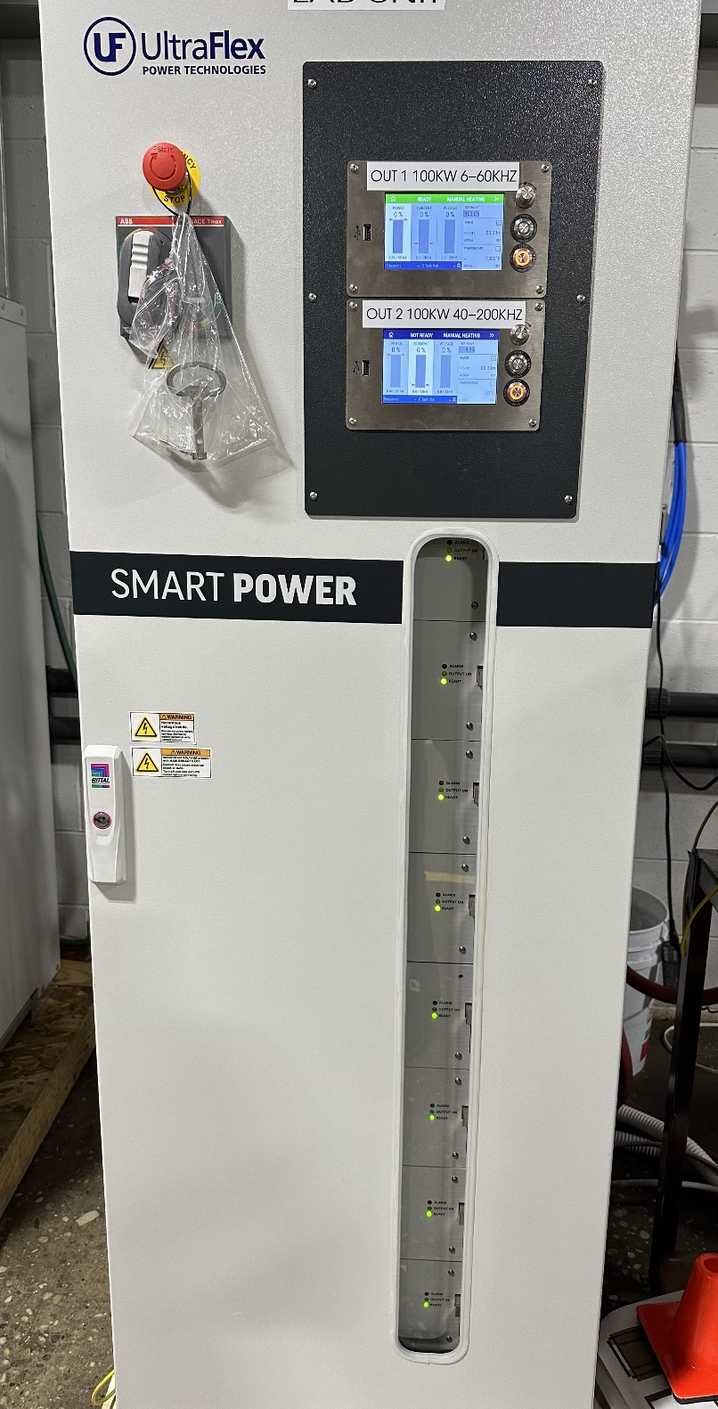

Connect your PC to SmartPower using *USB-RS485-WE-1800-BT* USB to RS485 converter cable .

Use the provided drawing for connector wiring.

Yellow-Brown is for RS485-B Pin 1

Orange-Green is for RS485-A Pin 2

Black is for Ground Pin 3

Install the MODBUS Software from Ultraflex Power Public Git Repository.

[Solo-Modbus-Software/latest_release at main · Ultraflex-Power/Solo-Modbus-Software (github.com)](https://github.com/Ultraflex-Power/Solo-Modbus-Software/tree/main/latest_release)

Run the software and click on Open.

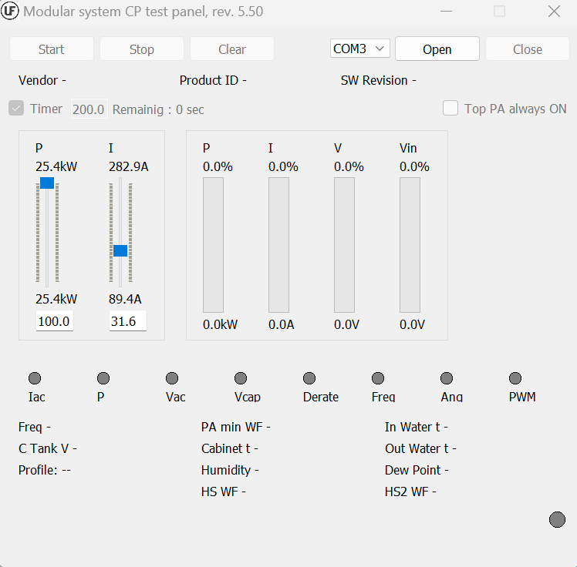

You should see the Green Indicator light on the right corner if the communication is established. It means power supply is in READY state.

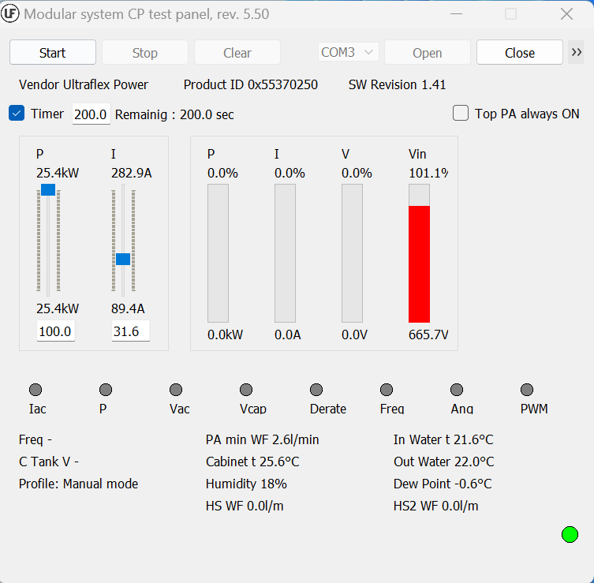

Go to Menu and click Config.

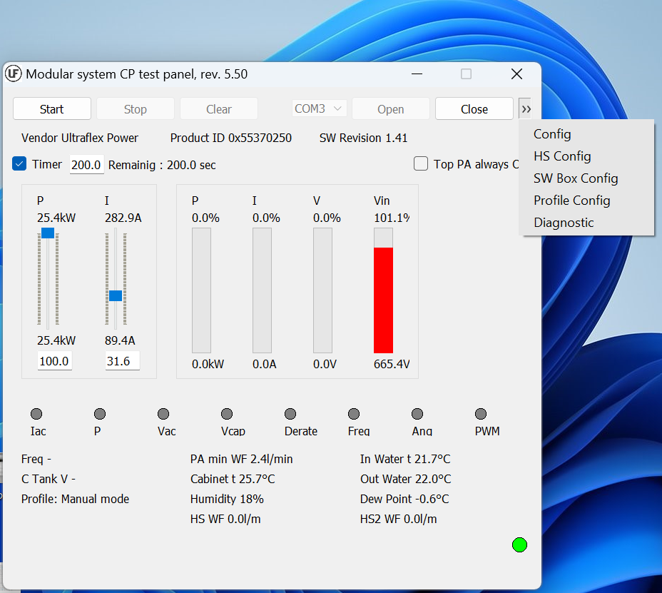

Select the address for the control panel you want to control. (Address previously must be assigned in the Control Panel interface)

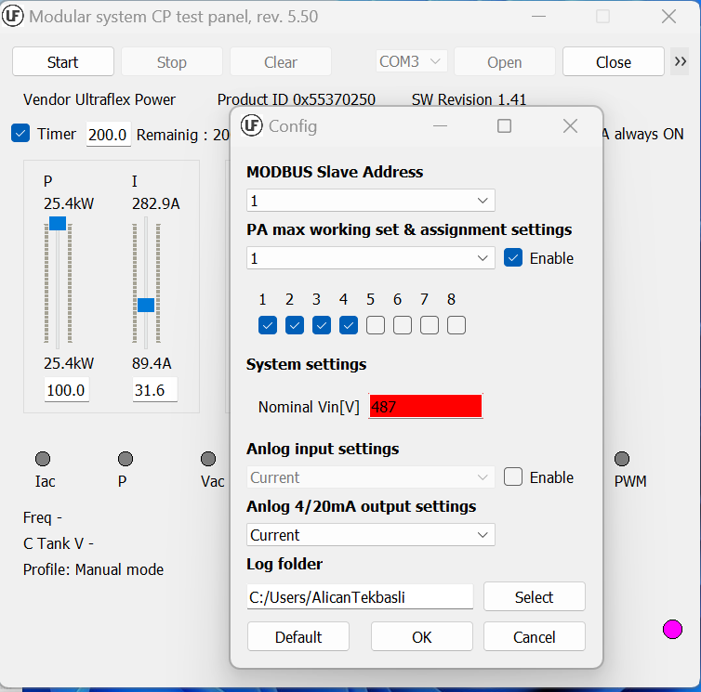

* Only PA Modules 1 through 4 can be controlled by Control Panel 1. Enable/Disable the PA modules you want to control by checking the boxes.
* Select the Output type you want to regulate as in kW or A .

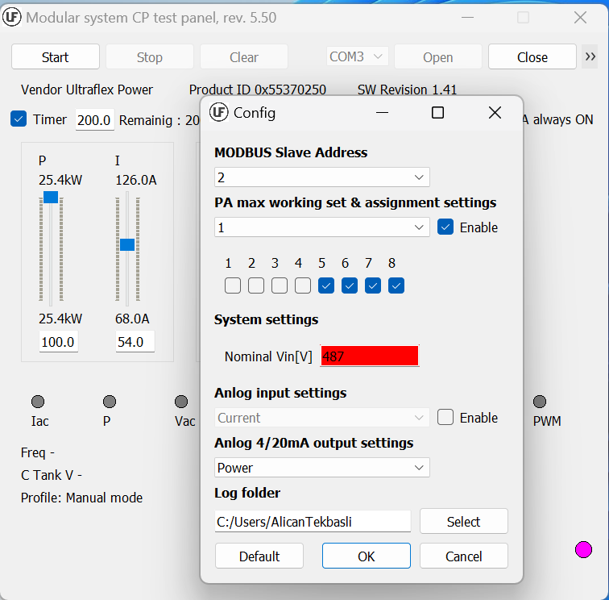

* Only PA Modules 5 through 8 can be controlled by Control Panel 2. Enable/Disable the PA modules you want to control by checking the boxes.

During configuration, indicator light on the right corner will be shown as Pink indicating Power Supply is not in READY state until the configuration is completed.

Click Start to start heating, output power and current can be monitored and manually controlled. Also Frequency, water temperatures, profile type is displayed on this screen.

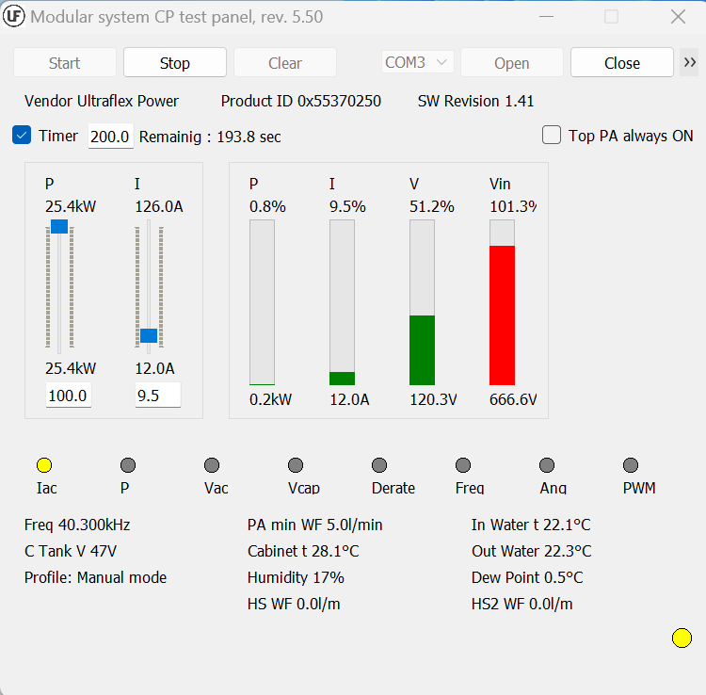

Indicator light on the right corner will be shown as yellow indicating its in HEAT state.

Heat Station settings can be displayed in HS Config Screen.

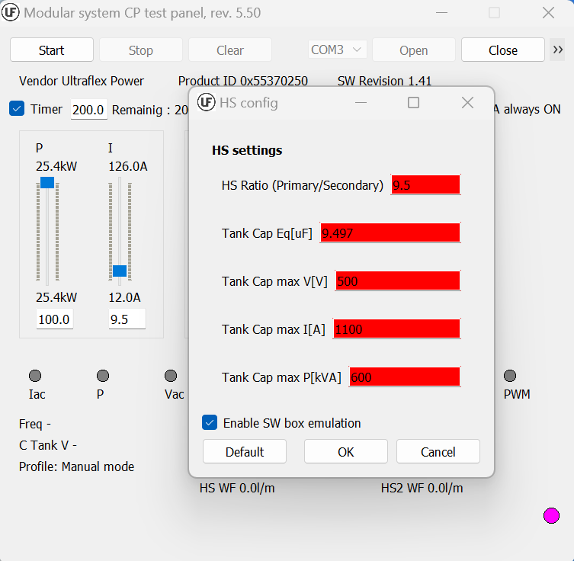

Tank Capacitor Settings can be adjusted here but its not recommended to change numbers without changing the capacitor in the heat station.

Profiles can be set in Profile Config Screen.

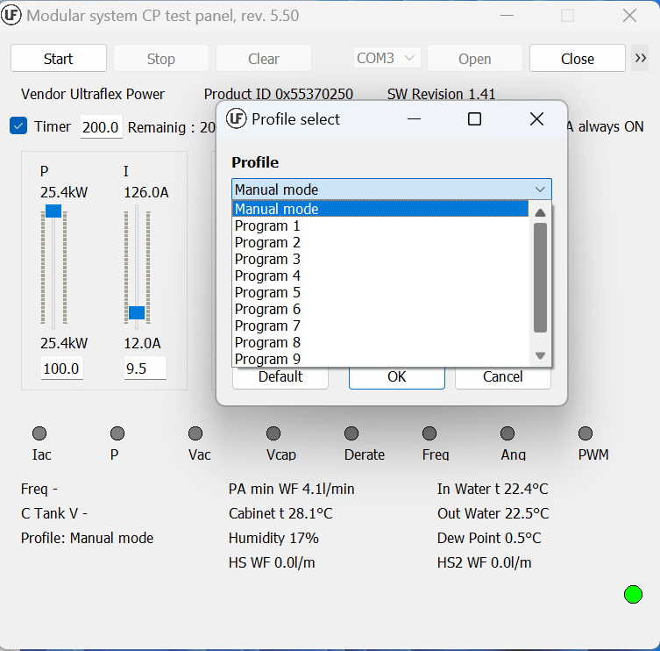

Select or create custom recipes for different applications.

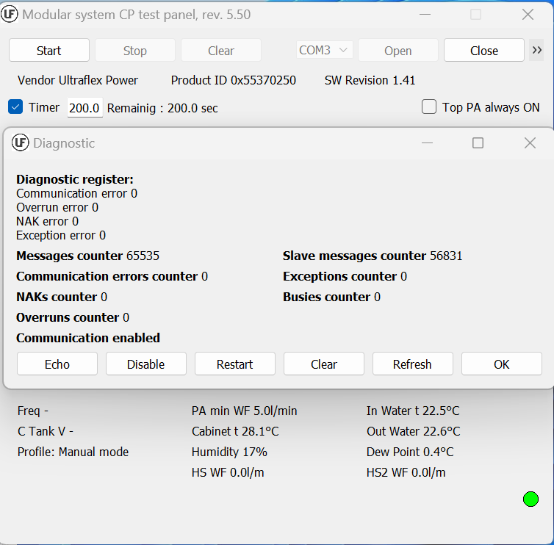

The diagnostic screen displays errors and messages about the power supply.